How to make a Spell Packet for Fantasy Youth LARP

https://moot82.wixsite.com/fantasy-youth-larp

fantasy.youth.larp@gmail.com

Spell Packets are constructed using cloth fabric and bird seed (finch seed is a good choice) which does not have sunflower or corn in the mix which could make them sharp on impact. I bought a 1.25 kg bag at the Dollar Store for about 4$ CA.

You may not use rice or any filler which expands when wet. Rubber balls are not allowed as they are too dense and the impact too hard when thrown.

Spell Packets can be easily made from cloth squares (cut 6”x6”) with about one tablespoon of bird seed in the centre, then folded into a ball, and tied with a rubber band. Be careful not to pack the seed too tightly.

Spell Packets which are obviously too large, or packed to tightly cannot be used. Spell Packets may be made in any colour you like. You are allowed to personalize your packets with distinctive markings and writing or use of patterned cloth.

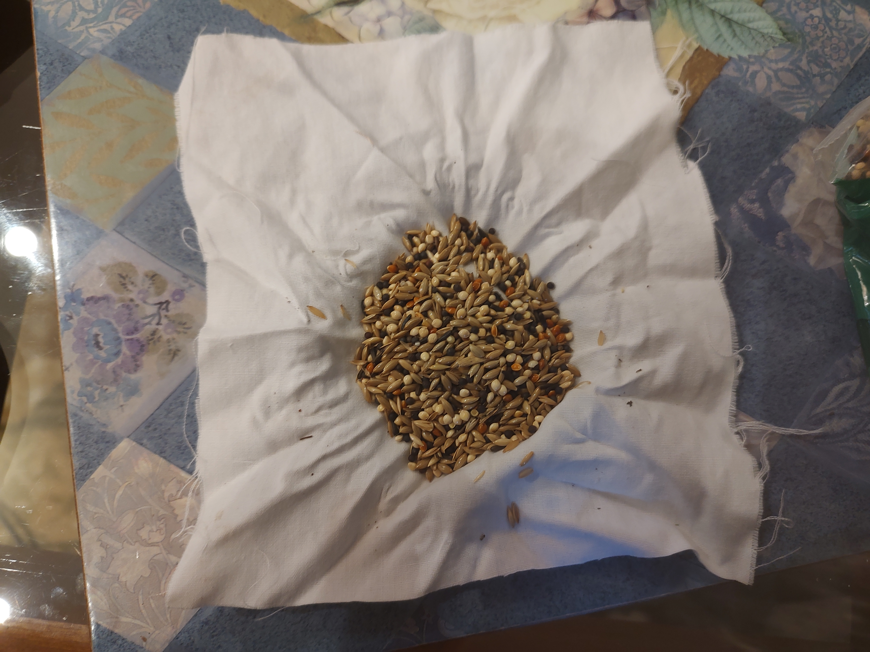
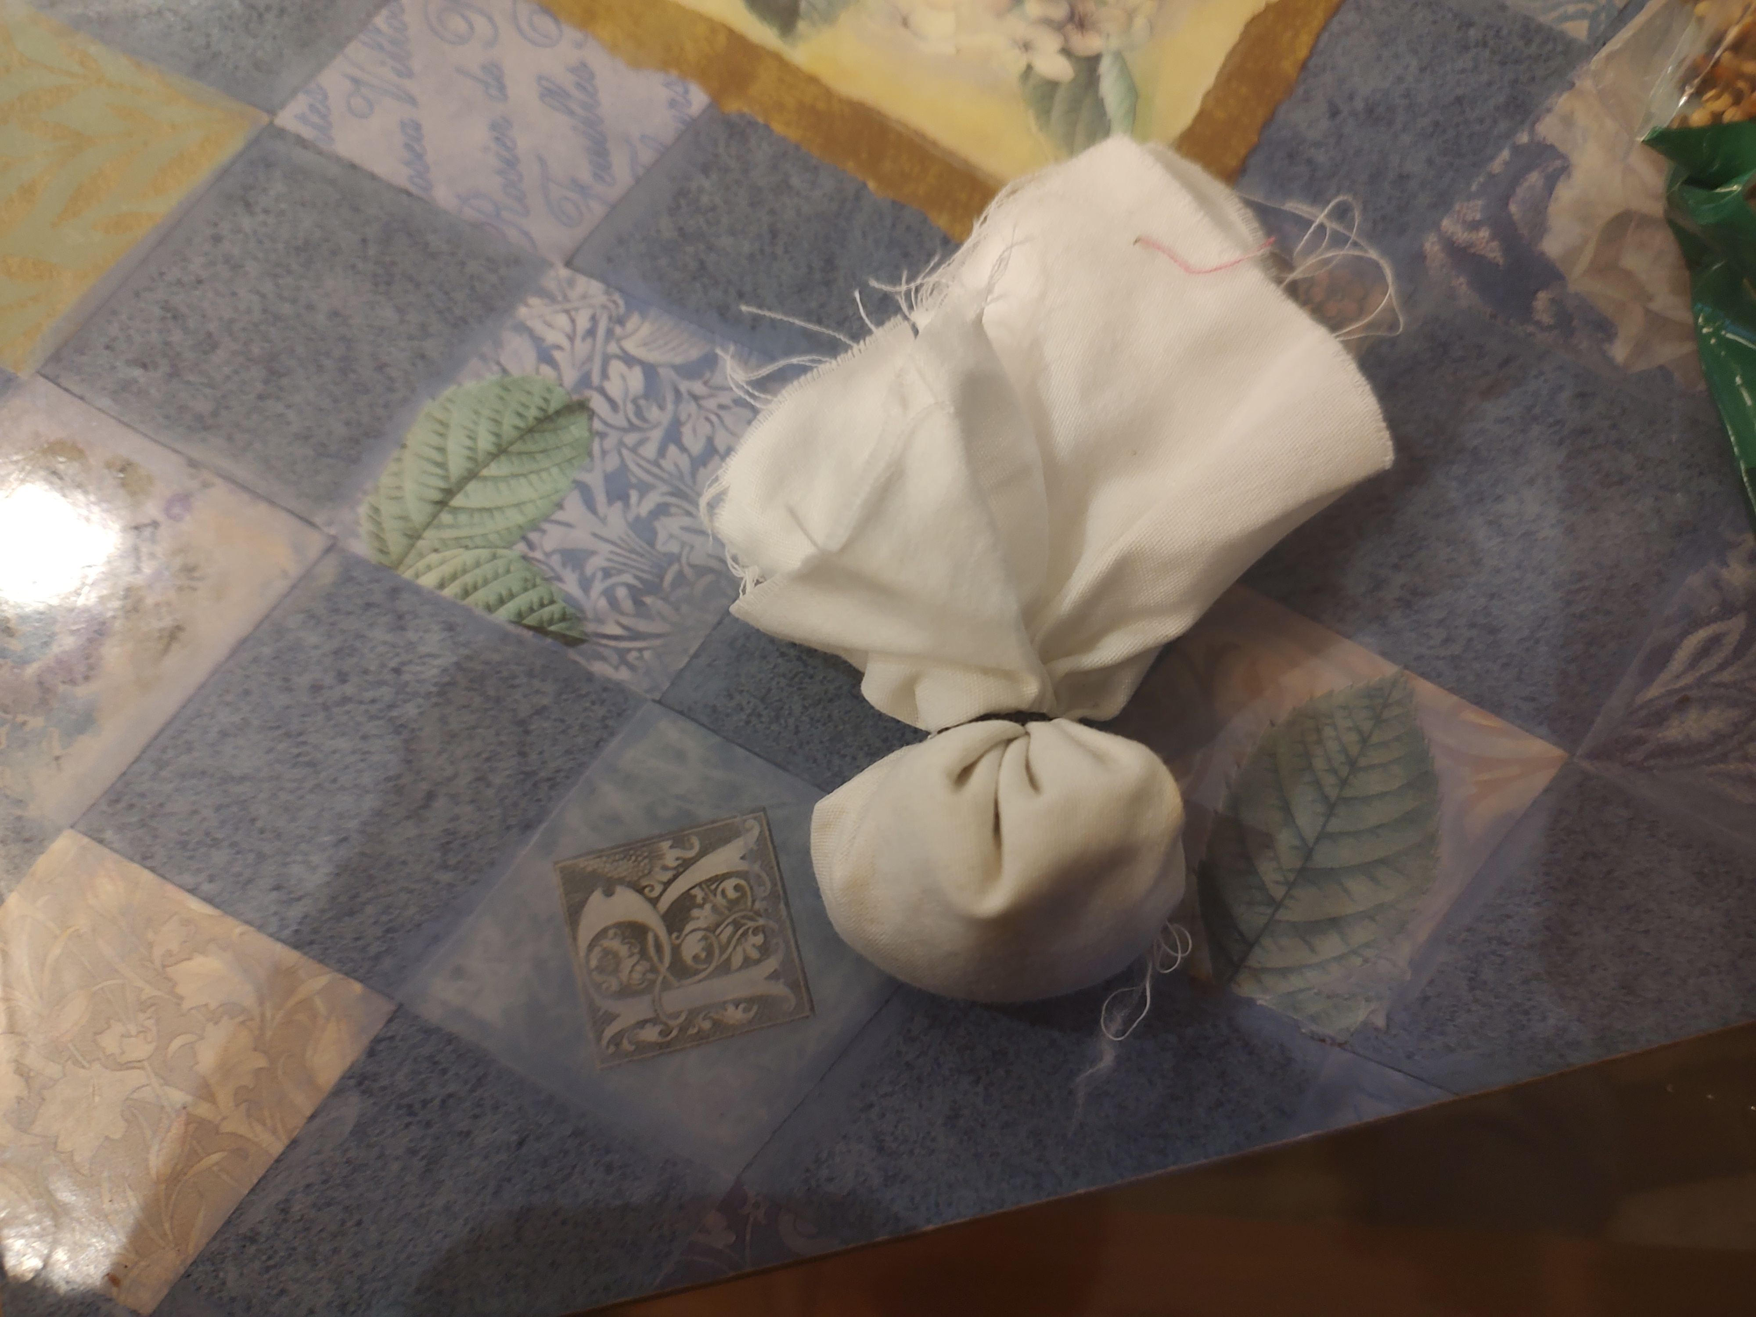

~Jesse

